Wireframe Documentation

Analysing Swiggy: Bangalore delivery outlet data

By

**Mamta M. Natu**

**Wireframe for Exploratory data analysis**

1. **Heat map: To find correlation between different attributes in data.**

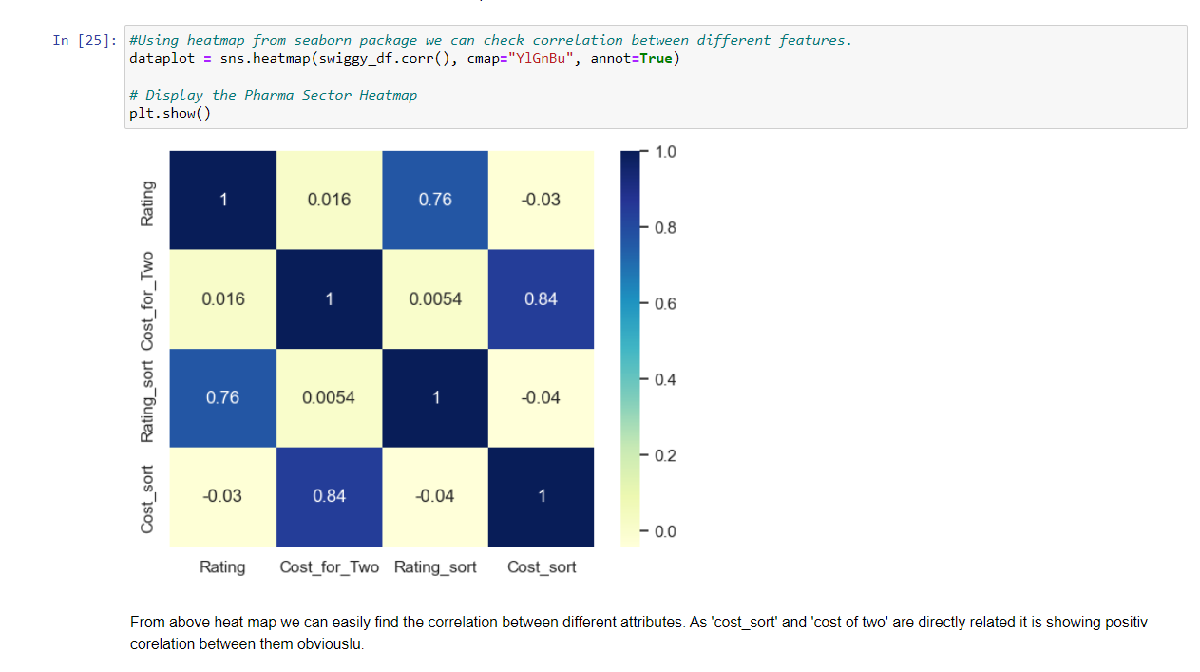

1. **Histplot: Histplot shows the distribution of ‘ratings’ count.**

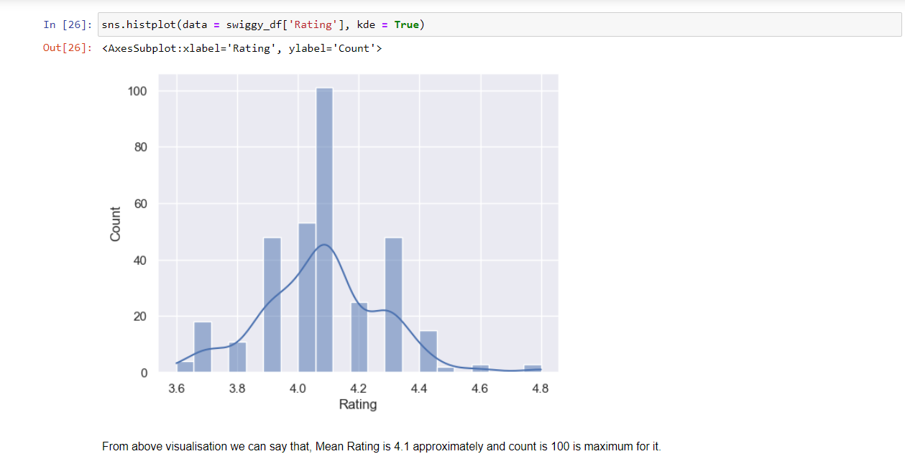

1. **Histplot: By plotting histplot of ‘cost_for_two’ on x axis and count on y axis gives distribution of its count.**

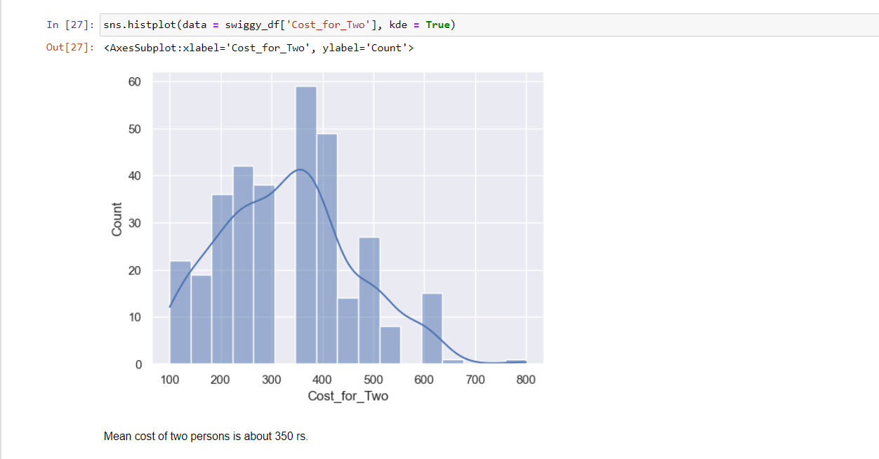

1. **Count plot: Location on x axis and count on y axis gives bins showing count of location.**

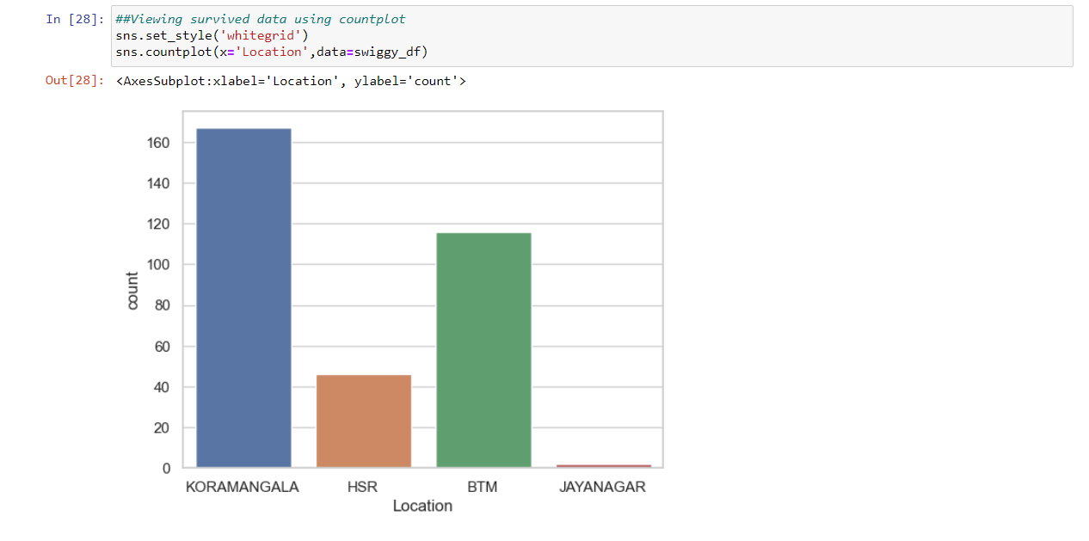

1. **Boxplot: Boxplot gives outliers in cost_for_two.**

Divide the "cost for two" in different categories

Cost_for_two>=200 🡺 Affordable=1,

200<Cost_for_two<500 🡺 Reasonable=2,

Cost_for_two>=500🡺 Premium=3

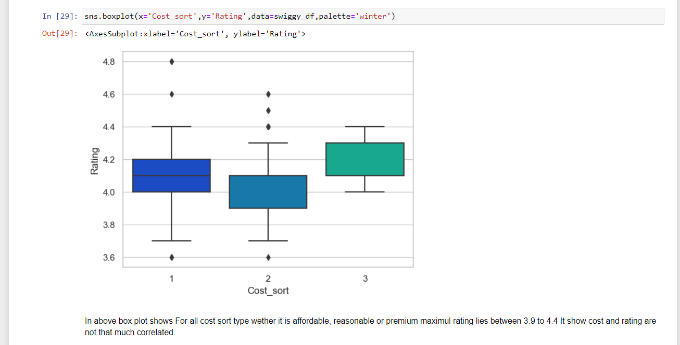

**6) Boxplot: Boxplot gives outliers in ratings. Also gives distribution of ratings.**

We divide Ratings in two halves, below and above average.

Ratings<4🡺below average ratings.

Ratings>=4🡺 above average ratings.

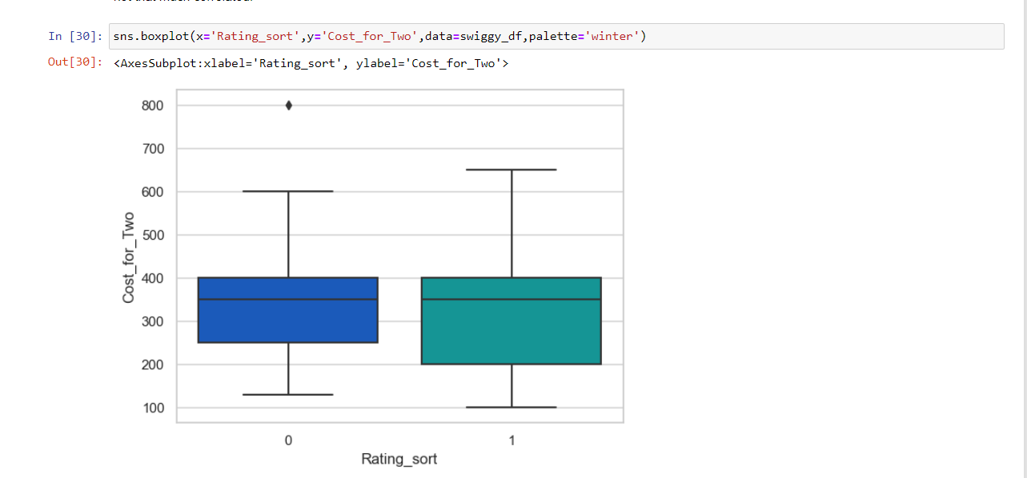

**Wireframe Documentation of PowerBi Report**

1. **Homepage: It gives overview on numeric analysis of swiggy data**

* It has slicers on Cuisine types and Location.
* Cards with different quantatitive information about data.
* Treemap showing distribution of shops over diferent Locations.
* Guages showing average ratings and average cost_for_two.
* Text box giving basic information about data.

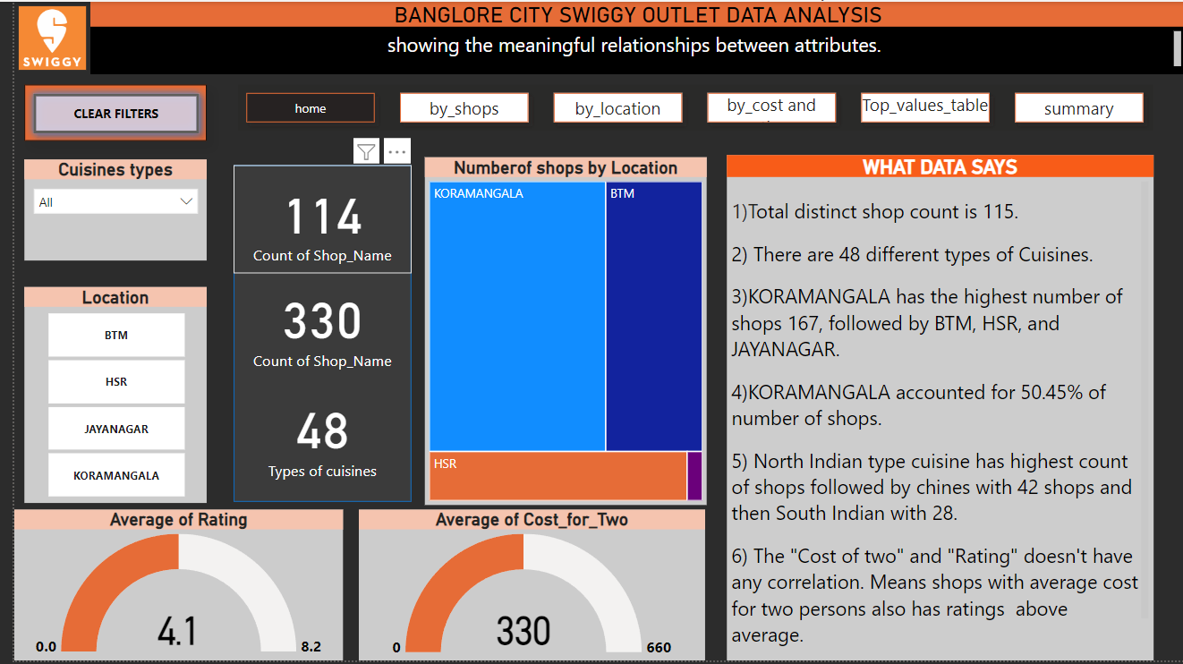

1. **Analysis of data by distinct_shop_Count:**

Decomposition tree, stacked column chart, cluster bar chart, line and cluster column chart, filled map used to show distribution of distinct shop count.

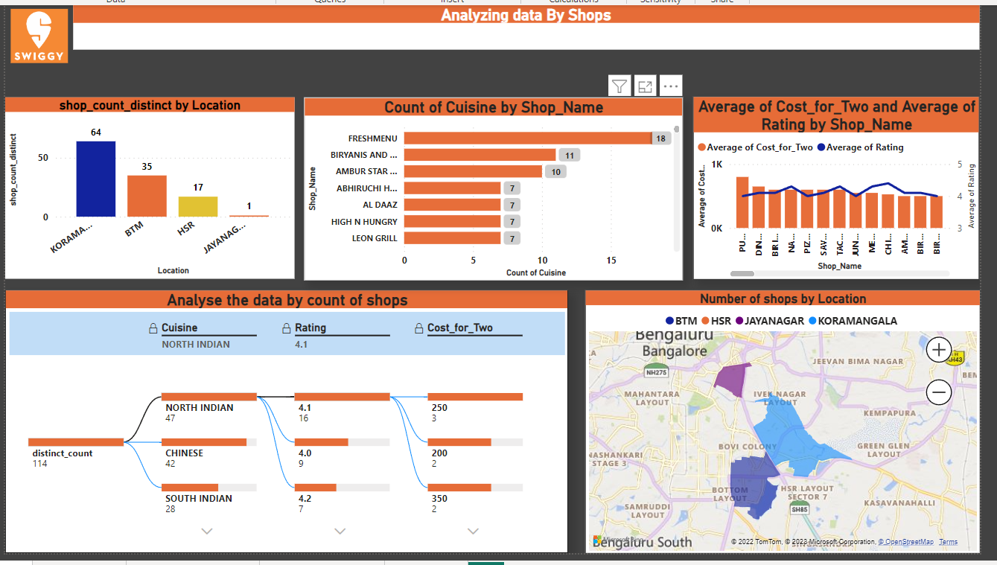

1. **Analysis of data by Location:**

Area chart, Ribbon chart, cluster bar chart, cluster line chart, cluster column chart, line and stacked column chart used to show distribution of different attributes by location.

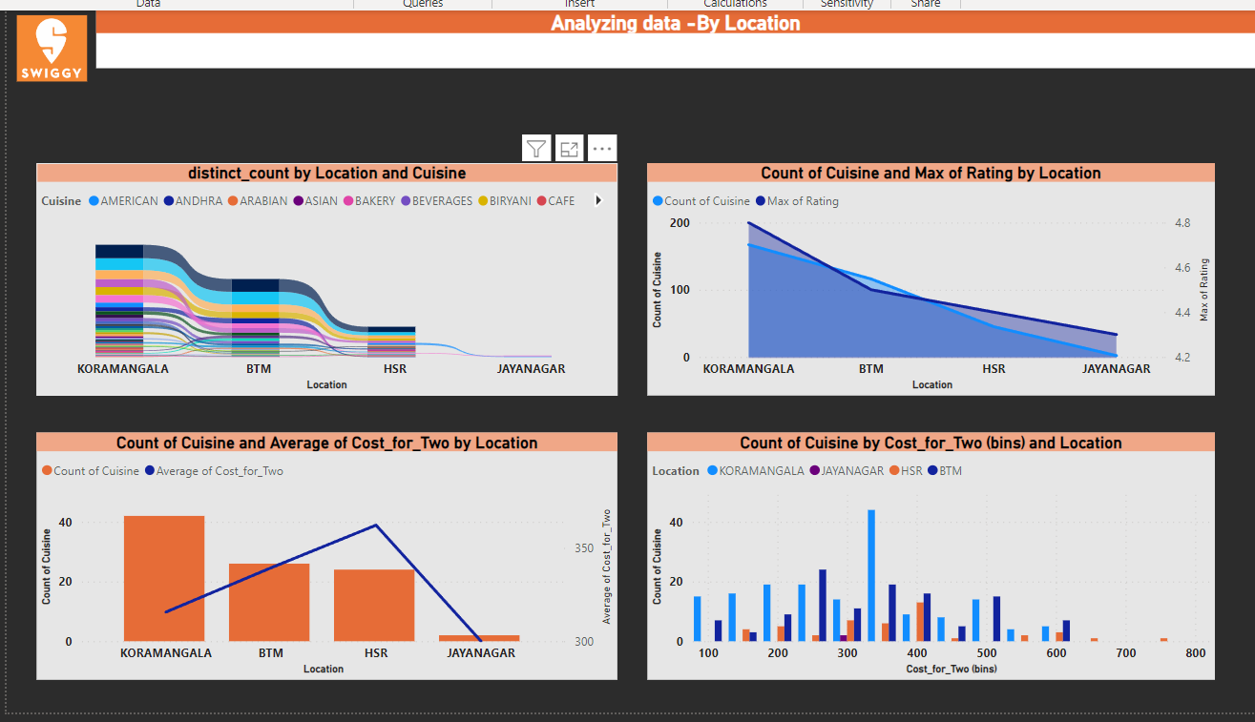

1. **Analysis of data by cost for two persons and ratings:**

Area chart, Line and stacked column chart, line , line and stacked column chart used to show distribution of cost for two and ratings.

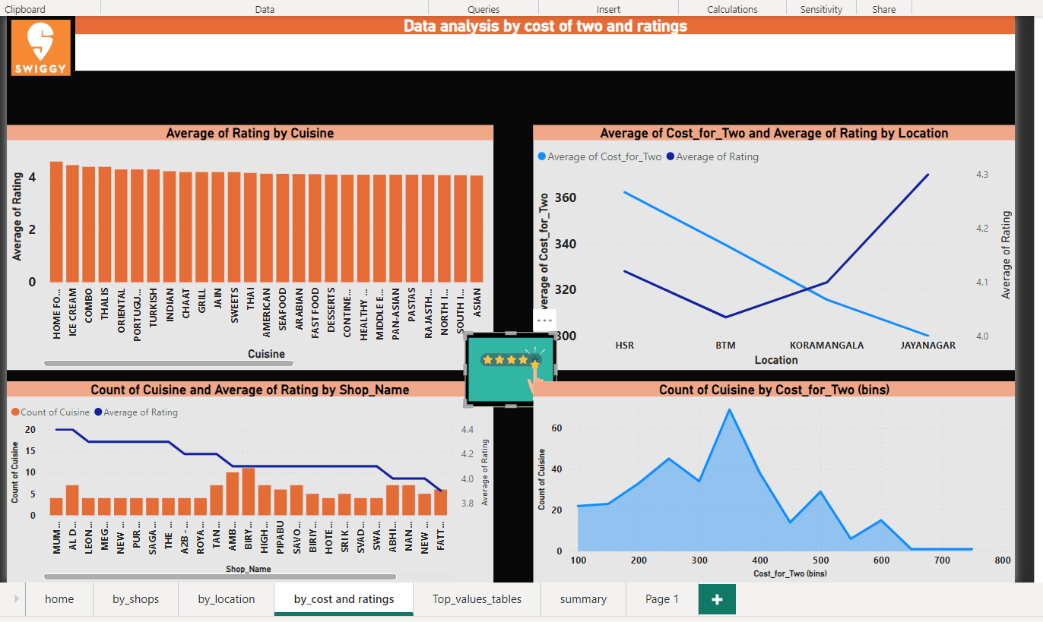

1. **Tables for top values of different attributes:**

* Top 5 cuisines with Maximum outlets
* Top shops with highest number if cuisines
* Top 5 cuisines by average cost for two
* Top 5 cuisines by average ratings
* Number of outlets by location.

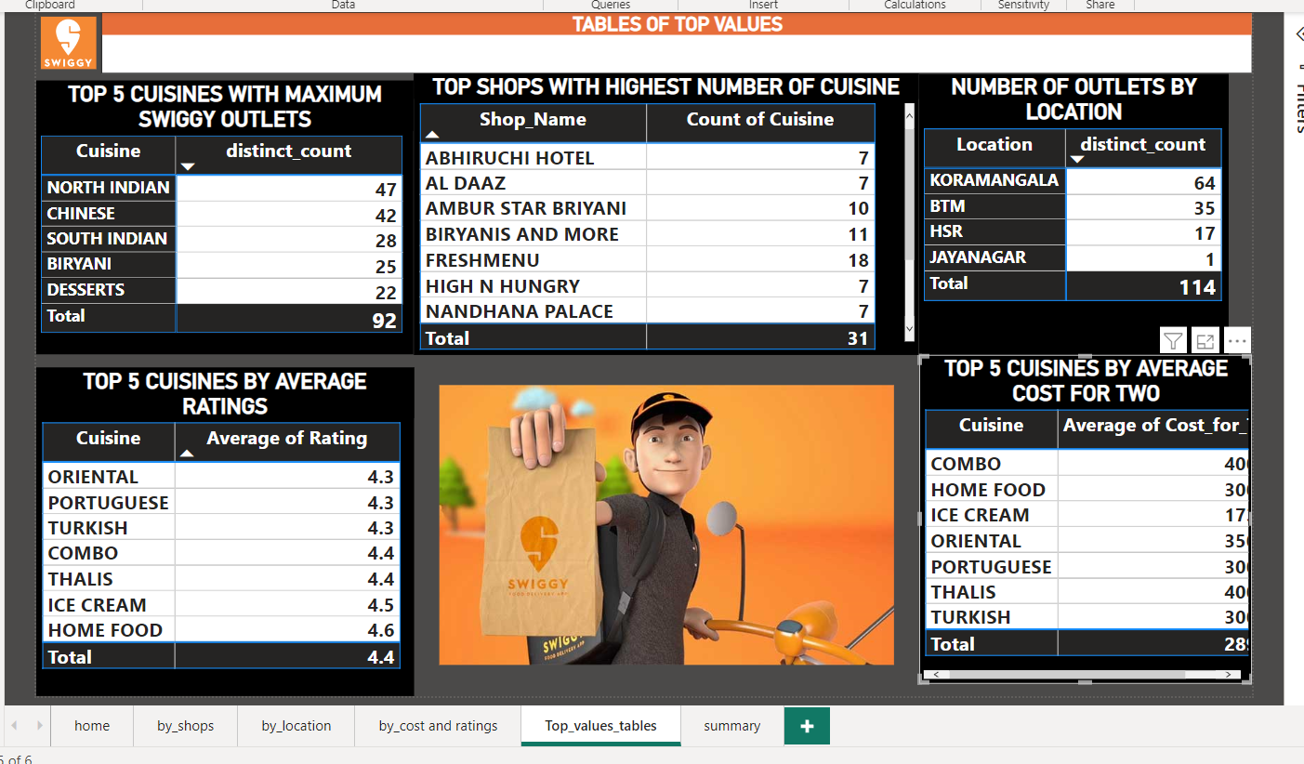

**6)Summary page:**

Heat map used to show correlation between differnet attributs in data.

Key influencer is used to find the effect of ratings on cost for two persons.

Text box showing question answer about relationship beween different attributes in data.

